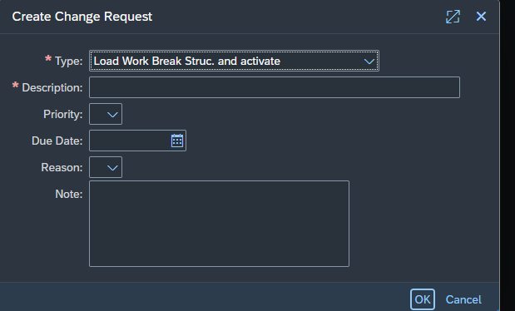

Project -> elemente -> hierachy -> texte

Download meines projects:

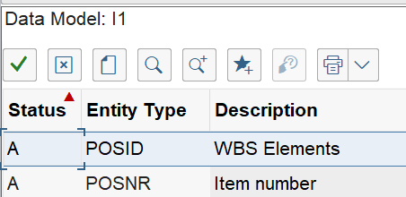
Warum keine T Tabelle???

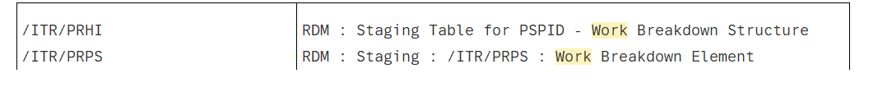

unchanged attributes - WBS Element.txt
- Download – done
- Upload:
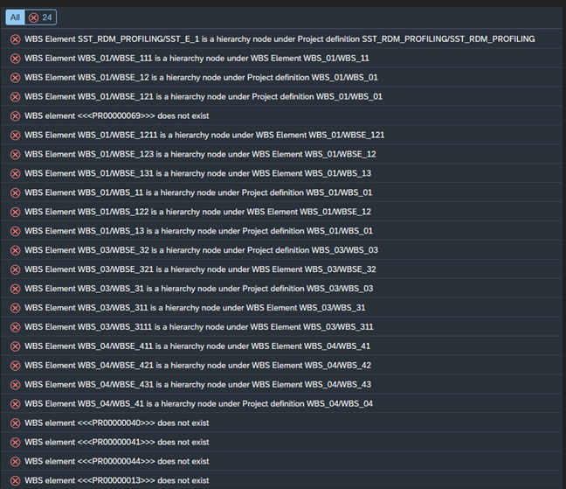

Upload new attributes - WBS Element - new attribute.txt
- Upload SST_UPL is not in active data after upload

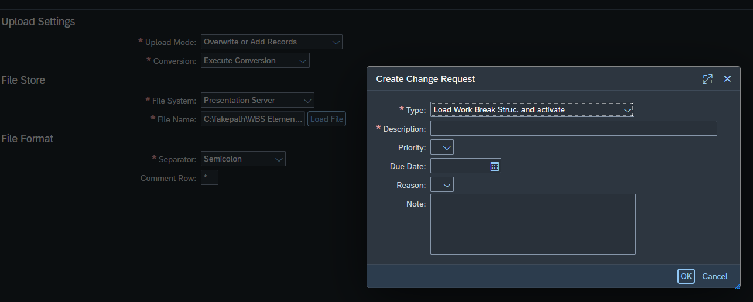

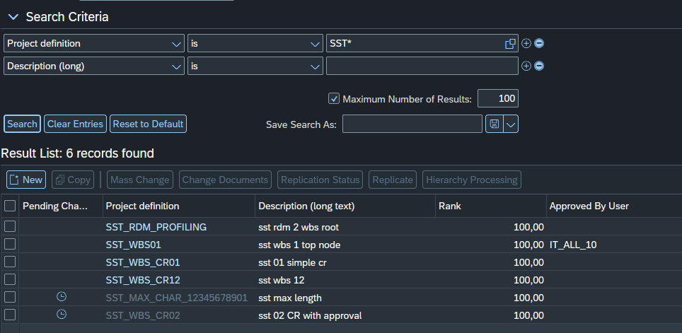

After upload

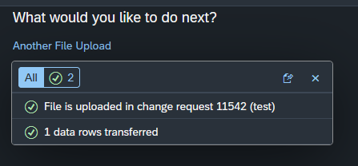

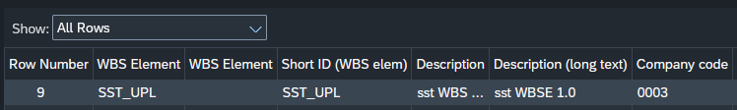
CR
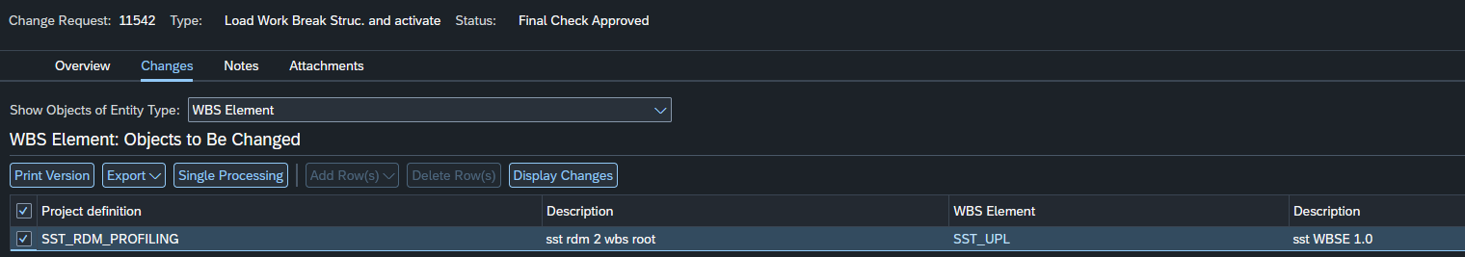

Upload with CR - 11544
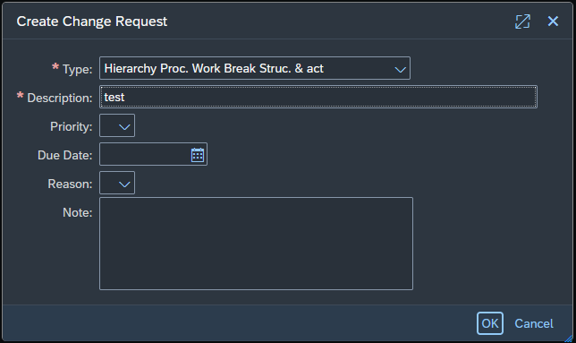

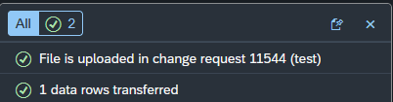

No change in active data
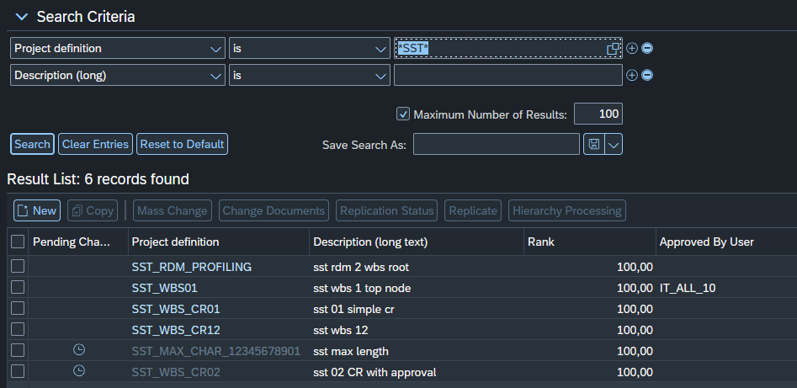

Not in active data after upload and activate: 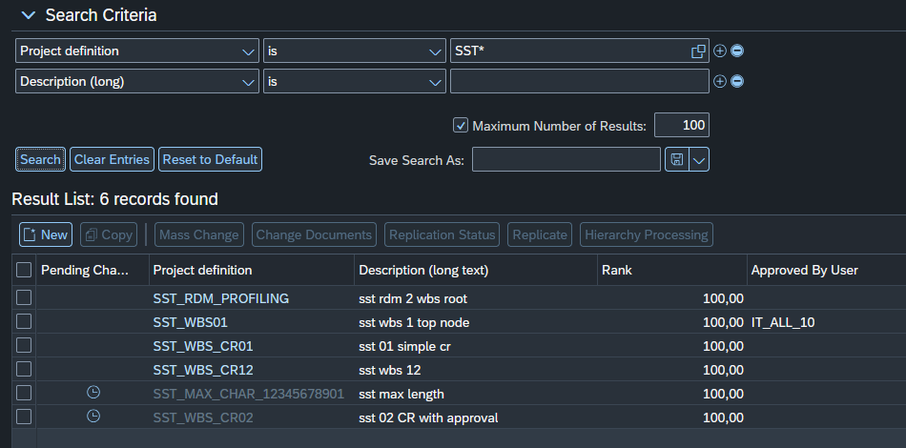

WBS Hierachie no project.txt
- Download – done
- Upload –
Unterschied zwischen upload und download bei hierachie ist die angabe des projects
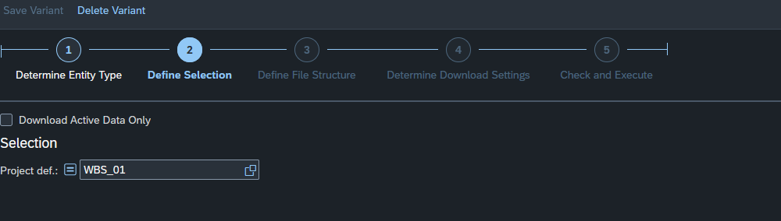

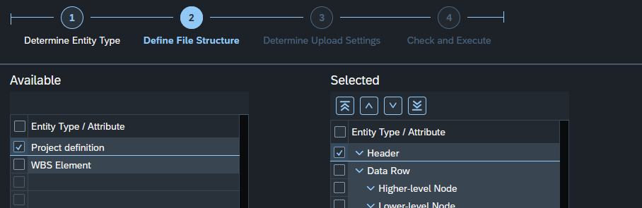
WBS new Hierachie new - no project.txt
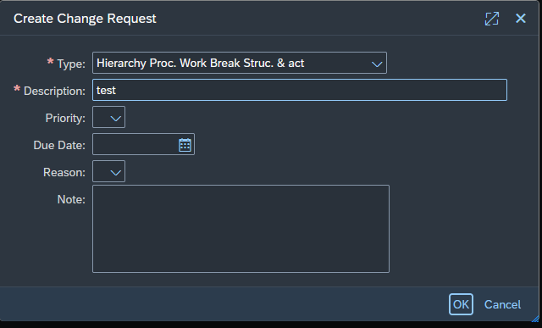

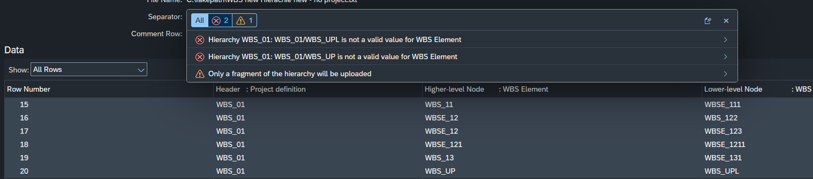

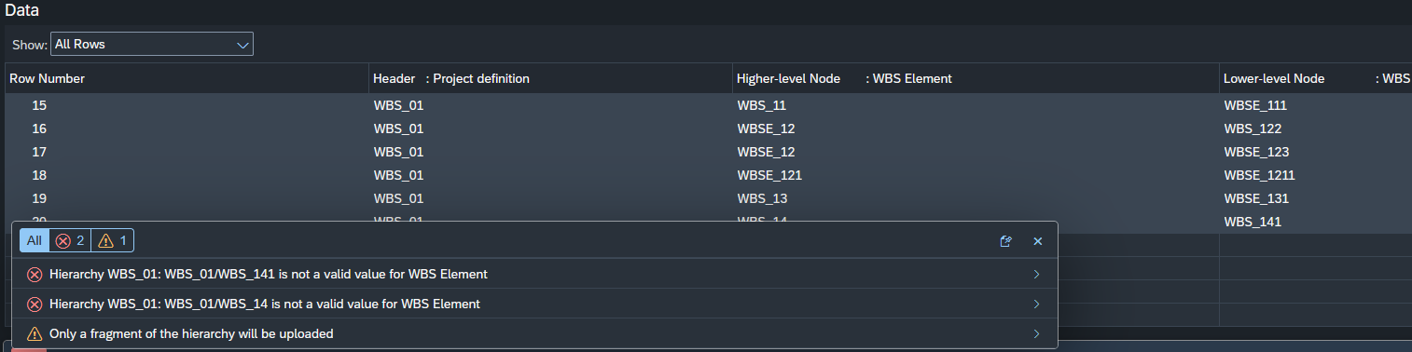

WBS Hierachie SST_RDM_PROFILING project.txt

download
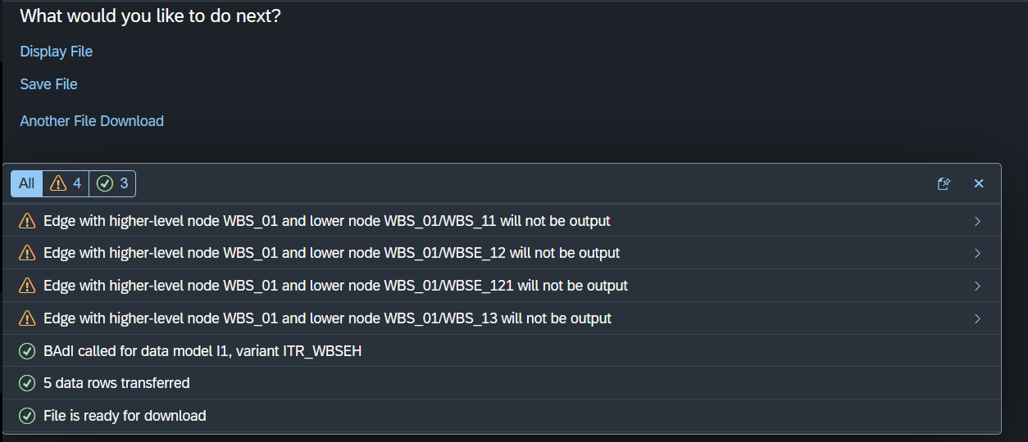

Upload new with project

